From NTRP 4-02.9/AFTTP 3-2.82/ATP 4-02.82, OCCUPATIONAL AND ENVIRONMENTAL HEALTH SITE ASSESSMENT
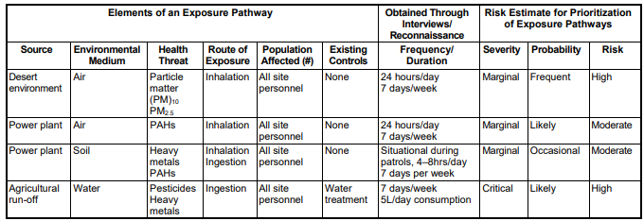
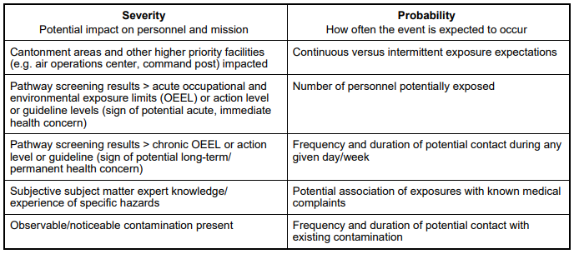
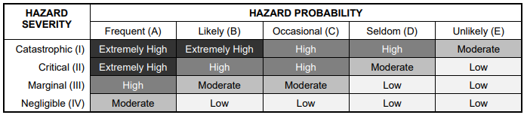

From TG 392, CSM Best Practices and Exposure Pathway Guidance
1.2 OCCUPATIONAL AND ENVIRONMENTAL HEALTH SITE ASSESSMENT An OEHSA is an iterative process used to identify and provide recommendations to manage OEH threats and their sources at a particular deployment site (e.g., base camp, airbase, forward operating base (FOB)) with complete or potentially complete exposure pathways to a current or future deployed population.
2.1 Conceptual Site Models A Conceptual Site Model (CSM) is a graphical, pictorial, and/or tabular depiction of what is known about a site in terms of what, where, when, why, to whom, and how exposures to health hazards may or may not occur. The CSM serves as the blueprint for understanding the situation, designing surveillance and sampling plans, identifying at-risk populations, describing health risks, and prioritizing risk management actions to control unacceptable risks. A CSM represents the compilation of all the exposure scenarios and their exposure pathways that are associated with a site.
2.2 Exposure Pathways An exposure pathway is traditionally defined as a description of how exposure occurs from a health hazard release from a source into the environment, transports through the environment and within one or more environmental media (air, water, soil, surfaces, etc.), the routes of human exposure (e.g., inhalation, ingestion, skin contact, etc.), and where and when specific personnel come into contact with the hazard (e.g., a specific cohort exposed at the same time or in a similar way). There are six components of an exposure pathway, each of which must be present in order for an actual exposure to occur: (1) source, (2) health hazard, (3) exposure point, (4) exposure medium, (5) route of exposure, and (6) co-occurrence in time with a population-at-risk. A key task in preparing to conduct a risk assessment is to describe the exposure pathways that the risk assessment will need to address
